Access to Finance and Business Support for Women-Led MSMEs in Lebanon

Women Economic Empowerment through advancing women-led enterprises in Lebanon (WEE) Program
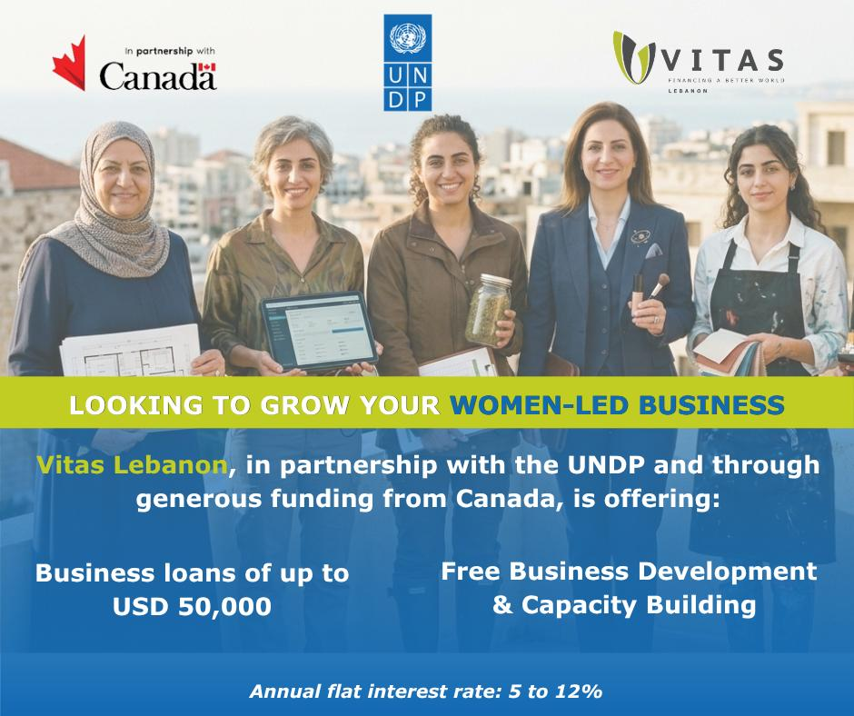

Background
The United Nations Development Program (UNDP), in partnership with Vitas s.a.l., is launching the Access to Finance Facility for Women-Led MSMEs in Lebanon as part of the Women’s Economic Empowerment through Advancing Women-Led Enterprises in Lebanon (WEE) Program, with the generous support of the Government of Canada.
The program aims to support gender-responsive job creation and economic empowerment by strengthening the capacity, resilience, and growth of women-led and women-owned Micro, Small, and Medium Enterprises (MSMEs) across Lebanon.
In the current economic context, characterized by limited access to finance, market disruptions, and operational constraints, MSMEs, particularly those led by women, face significant barriers to sustainability and growth. This program is designed to address these challenges by providing integrated financial and business support, enabling enterprises to stabilize, grow, and contribute to economic recovery.

Objective
The objective of is to identify and support eligible women-led and women-owned MSMEs to benefit from:
- Business loans
- Targeted technical assistance to strengthen financial management and improve access to markets
The program seeks to enhance the ability of MSMEs to strengthen their operations, improve financial management, expand their activities, and generate employment opportunities.

Scope of Support

3.1 Financial Support
Selected beneficiaries will be eligible to access business loans, with the following indicative parameters:
- Loan amounts ranging from USD 10,000 to USD 50,000, with repayment terms of 18–24 months and flat interest rates ranging from 5% to 12% per annum (the rate applicable to each loan will be determined during the credit evaluation process, taking into account the applicant's financial standing, repayment capacity, business and sector risk, loan structure, and any available guarantee).
- Repayment terms will be determined on a case-by-case basis following credit assessment, based on the MSME’s loan amount, cash flow, and risk profile
- Financing may be disbursed for:
  - Working capital
  - Purchase of equipment and machinery, including energy-efficient equipment
  - Improvement of production processes (including research and development processes) and service delivery
- Not covered:
  - Utilities and office rent
  - Per diem or daily allowances
  - Motor vehicles unless clearly necessary for business operations
  - Activities that are illegal, harmful, or otherwise excluded under facility rules

All applications will be subject to credit assessment and due diligence process.

3.2 Targeted Technical Assistance Program:
Selected MSMEs will also benefit from:
- Financial literacy trainings to improve financial planning, cost management and cash flow monitoring
- Tailored advisory and coaching support to access new markets
- Visibility through a digital business matchmaking platform connecting eligible MSMEs to potential investors
The completion of the technical assistance component is mandatory for loan beneficiaries.

Eligibility Criteria

4.1 Business Eligibility
Applicants must meet the following criteria
- Legally registered Lebanese MSMEs with fewer than 50 full-time employees
- MSMEs operating in the Agrifood, Cosmetics, Personal care and cleaning products, Creative Industries as well as Tech and Tech enabling sectors
- MSMEs must be operating for more than 1 year
- The business is active and generating revenue
- The business qualifies as a micro, small, or medium enterprise (MSME)

4.2 Women’s Contribution in the Business:
The business must meet at least one of the following conditions:
- Women-Owned: ≥ 51% of the business is owned by woman/women, as per the shareholder agreement
- Women-Led:
  - <51% ownership/stake by a woman or women and the business has ≥ 1 woman in a leadership position (such as CEO/COO/CFO/Managing Director, Director)
  - Female employees represent between 50%-100% of total workforce (counting full-time employment only)
  - For Micro Enterprises (with less than 5 employees): A business is considered women-led if a woman oversees its core operations or production processes, or holds operational management responsibilities (e.g., Lead Chemist, Quality Manager, Factory Manager, Operations Manager), even if female employment represents less than 50% of the total workforce.

4.3 Sector Eligibility
Eligible businesses must operate in one of the following sectors:
- Agrifood (including logistics and cold storage services for food security)
- Cosmetics, personal care and cleaning products
- Creative industries (including crafts, textiles, furniture, jewelry, design, and related activities)
- Tech and tech enabling sectors

Selection and Prioritization Criteria
Applications will be evaluated through a structured assessment process. While all eligible applications will be reviewed, priority will be given to businesses that demonstrate the strongest overall alignment with the following criteria:
- Strong potential for job creation or job retention, particularly for women
- Clear evidence of business viability and growth potential
- Demonstrated need for financial support to sustain or expand operations
- Women-owned or women-led businesses where women hold primary decision-making over strategic, financial and operations processes
- Priority is given to businesses with export potential
The selection process will ensure a balanced representation across sectors, business sizes, and geographic areas, in line with program objectives.

Selection Process
The selection process will be conducted in the following stages:
Stage 1: Application Submission
Applicants submit the required information and documentation through a dedicated online portal, as well as Vitas branches and outreach channels.
Stage 2: Evaluation and Screening
Applications are assessed based on eligibility and prioritization criteria.
Stage 3: Shortlisting
Shortlisted applicants may be subjected to a site visit to the production facility and requested to provide additional documentation or clarifications.
Stage 4: Final Selection
Final beneficiaries are selected based on overall assessment and program alignment.

Application Requirements
Applicants will be required to submit:
- Basic personal and business information
- Description of business activity
- Information on revenues, costs, and financial practices
- Explanation of financing needs and intended use of funds
Additional documents may be requested during the evaluation process.

Geographic Coverage
The program is open to eligible applicants across all Lebanese governorates, with a commitment to ensuring inclusive geographic coverage, particularly in underserved and vulnerable regions.

Additional Conditions
- Submission of an application and requested documents do not guarantee selection or financing
- Applicants must provide accurate and complete information
- Selected beneficiaries must comply with program requirements, including training and reporting.

Contact Information
For further information:
- Email: info@vitaslebanon.com
- Phone: +961 70800811

Disclaimer
UNDP and Vitas reserve the right to verify all submitted information and to make final decisions regarding eligibility, selection, and participation in the program.

Not covered Utilities and office rent Per diem or daily allowances Motor vehicles unless clearly necessary for business operations Activities that are illegal, harmful, or otherwise excluded under facility rules
As per the Ministry of Industry definition

